**IMAGE ENHANCEMENT FOR BETTER VISUALIZATION**

*A project report submitted in partial fulfilment of the requirements for the degree*

*of*

**MASTER OF COMPUTER APPLICATION (MCA)**

OF

**TEZPUR UNIVERSITY**

2021



*Submitted by*

**HARI OM JEE (CSM20010)**

**CHINMAY CHANDRA DAS (CSM20039)**

*Guided by*

**DR. BHOGESWAR BORAH**

PROFFESSOR & HEAD

DEPARTMENT OF COMPUTER SCIENCE & ENGINEERING

**TEZPUR UNIVERSITY**

TEZPUR 784028

ASSAM.



This project titled “Image Enhancement for better Visualization” submitted by Hari om jee (CSM20010) and Chinmay Chandra Das (CSM20039) in partial fulfilment of the requirements for the minor project of Master of Computer Applications has been examined.

**Examiner:**

**Date:**

**Place : Tezpur**



**CERTIFICATE**

This is to certify that the dissertation entitled “**Image Enhancement for better Visualization**” is submitted by **Hari om jee** bearing Roll no: **CSM20010** and **Chinmay Chandra Das** bearing Roll no: **CSM20039** is carried out by her under my supervision and guidance for partial fulfilment of the requirements and the regulations for the award of the degree of Master of Computer Applications during the session 2020-2022 at Tezpur University. To the best of my knowledge, the matter embodied in the dissertation has not been submitted to any other university/institute for the award of any Degree or Diploma.

Date:  **Dr. Bhogeswar Borah**

Place**:** Professor & Head

Department of Computer Science & Engineering

                                                                                                                   Tezpur University



**DECLARATION**

We hereby declare that the project work titled “**Image Enhancement for better Visualization”** submitted to the Department of Computer Science and Engineering, Tezpur University is prepared by us and was not submitted to any other institution for award of any other degree.

Date:  **Hari om jee (CSM20010)**

**Chinmay Chandra Das(CSM20039)**

Place**:**  Department of Computer Science & Engineering

                                                                                                                   Tezpur University

**ACKNOWLEDGEMENT**

We would like to express my special thanks to our guide and HOD Dr. Bhogeswar Borah and Dean of School of Engineering Dr. Smriti K. Sinha, Tezpur University to give us the opportunity to do this project on the topic Image Enhancement for better Visualization which is a GUI based application, which also helped me in doing a image processing and I came to know about so many new things about various Enhancement techniques and their applications and lot more, I am really thankful to them.

Hari om jee(CSM20010) Chinmay Chandra Das(CSM20039)

**Abstract**

The field of Digital Image Processing refers to processing digital images by means of digital computer. One of the main application areas in Digital Image Processing methods is to improve the pictorial information for human interpretation. Most of the digital images contain noise. This can be removed by many enhancement techniques. Filtering is one of the enhancement techniques which is used to remove unwanted information (noise) from the image. It is also used for image sharpening and smoothening. This project has been developed using Python language because of its universal acceptance and easy understandability.

**CONTENTS**

**Chapter 1 Introduction**

Image Processing

Problem Statement

**Chapter 2 Image Enhancement**

* 1. Purpose
  2. Image Enhancement Techniques
     1. Techniques Types
  3. Advantages of Domain
  4. Spatial Domain
     1. Point Processing
     2. Spatial Filtering
        1. Smoothing
        2. Sharpening
  5. Frequency Domain
     1. Filters
        1. Low pass
        2. High pass

**Chapter 3 Data Flow Diagram**

**Chapter 4 Requirements Specifications**

**Chapter 5 Experiment**

**Chapter 6 Future Scope**

**Chapter 7 Conclusion**

**Chapter 1. INTRODUCTION**

The precept goal of enhancement strategies is to procedure a photograph in order that the end result is extra appropriate than the unique photograph for a selected application. Digital photograph enhancement strategies offer a mess of alternatives for enhancing the visible first-rate of pictures. Appropriate preference of such strategies is substantially stimulated with the aid of using the imaging modality, mission handy and viewing conditions. Image enhancement is largely enhancing the interpretability or notion of facts in pictures for human visitors and providing `better' enter for different automatic photograph processing strategies. The main goal of photograph enhancement is to alter attributes of a photograph to make it extra appropriate for a given mission and a selected observer. During this procedure, one or extra attributes of the photograph are changed. The preference of attributes and the manner they're changed are precise to a given mission. Image enhancement plays a chief function in photograph processing features in which humans make choices with admire to the photograph facts. Form of photograph enhancement include noise reduction, facet enhancement and difference enhancement

* 1. **IMAGE PROCESSING**

Digital image processing is the use of computer algorithms to perform image pro-

cessing on digital images. As a subcategory or field of digital signal processing,

digital image processing has many advantages over analogue image processing. It allows a much wider range of algorithms to be applied to the input data and can avoid problems such as the build-up of noise and signal distortion during processing. Since images are defined over two dimensions (perhaps more) digital image processing may be modelled in the form of multidimensional systems. Digital filters are used to blur and sharpen digital images. Filtering can be performed in the spatial domain by convolution with specifically designed kernels (filter array), or in the frequency (Fourier) domain by masking specific frequency regions.

**Advantages**

Digital Image Processing in the most layman terms is image editing to improve

it's visual appearance but not limited to it. The main advantages are: -

* Important features such as edges can be extracted from images which can

be used in industry.

* Images can be given more sharpness and better visual appearance.
* Minor error can be rectified.
* Image size can be increased and decreased.
* Images can be compressed and decompressed for faster image transfer over

the network.

* Images can be smoothened.
* It allows robots to have vision.
* Removing noise from the images.
* Sharpening of image.

**Application in Real World**

There are many applications of image processing in the real world. Some of them

are listed below: -

Image Enhancement, Image Restoration, Character recognition, Signature

verification, Biometrics, Fingerprint verification, Face Detection, Medical Ap-

plication, Digital Cinema, Image Transmission and coding, Robot vision, Hybrid

Techniques, Pattern Recognition, Video Processing, and Weather Forecasting.

* 1. **Problem Statement**

**GOAL** -

The goal of this project is to include a picture process victimisation numerous image processing technique like deblurring, denoising, exposure correction, high filter boosting ,etc. to extend the standard of the image for the viewer. The image processing unit can primarily perform several tasks up the distinction of the image and removing any artefacts and noise introduced as a results of contrast enhancement. Offer the scholars a general understanding of the basics of digital image processing. Introduce the students to analytical tools that are presently utilized in digital image processing as applied to image data for human viewing. Develop the scholars ability to use these tools within the laboratory in image restoration, sweetening and compression.

**SCOPE** -

Image processing is being applied in many fields in today's world

**Automotive sector**: In developing advanced drivers assist for semi-autonomous cars and also heavily used in autonomous/driver-less cars.

**Image enhancing**: The camera applications in smart phones and digital cameras using image processing to enhance the image quality, video stabilization and noise removal etc.

**Robotics**: Mobile robot's navigation in unknown environment (SLAM), control of the robot by processing the video feed from the camera on robot to

extract the live scene around it.

**Gaming**: Advanced gaming consoles like Xbox Kinect uses image processing from motion analysis of the human player.

**Problem specific solutions**: Image processing is used as a solution to a variety of problems, starting from facial recognition access to defects identification in manufacturing industries.

**Manufacturing**: To identify defects in the processes and also to control the robots in performing certain tasks. for ex. defects in manufacturing of a Printed Circuit Board (PCB) can be observed using high resolution image processing.

**Human machine interface**: Machines are made smart by adding gestural interface, or human action response interfaces, which decodes the actions of the human user to perform certain tasks.

**Chapter 2. Image Enhancement**

In image enhancement, the goal is to accentuate certain image features for subsequent analysis or for image display. Examples include contrast and edge enhancement, noise filtering, sharpening, and magnifying. Image enhancement is useful in feature extraction, image analysis,

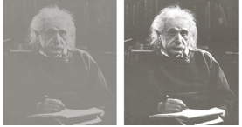 and visual information display enhancement

process itself does not increase the inherent

information content in the data.

It simply emphasizes certain specified image

characteristics. Enhancement algorithms are

generally interactive and application-dependent. Image enhancement is among the simplest and most appealing areas of digital image processing.

Basically, the idea behind enhancement techniques is to bring out detail that is obscured, or simply to highlight certain features of interest in an image. A familiar example of enhancement is shown in Fig. in which when we increase the contrast of the image and filter it to remove the noise "it looks better." It is important to keep in mind that enhancement is a very subjective area of image processing. Improvement in quality of these degraded images can be achieved by using application of enhancement techniques.

* 1. **PURPOSE**

The aim of image enhancement is to improve the visual appearance of an image or to provide a “better transform representation for future automated image processing”. Unfortunately, there is no general theory for determining what `good’ image enhancement is when it comes to human perception. If it looks good, it is good! However, when image enhancement techniques are used as pre-processing tools for other image processing techniques, then quantitative measures can determine which techniques are most appropriate.

* 1. **IMAGE ENHANCEMENT TECHNIQUES**

Image enhancement process consists of a collection of techniques that seek to improve the visual appearance of an image or to convert the image to a form better suited for analysis by a human or machine. The principal objective of image enhancement is to modify attributes of an image to make it more suitable for a given task and a specific observer. During this process, one or more attributes of the image are modified. Digital Image enhancement techniques provide a multitude of choices for improving the visual quality of images. Appropriate choice of such techniques is greatly influenced by the imaging modality, task at hand and viewing conditions. A familiar example of enhancement is in which when we increase the contrast of an image and filters it to remove the noise "it looks better". It is important to keep in mind that enhancement is a very subjective area of image processing. Improvement in quality of these degraded images can be Achieved by using application of enhancement techniques.

* An image enhancement operation is applied to an image f(x,y) to produce an enhanced image. This is denoted mathematically as *g(x,y)= T[ f(x,y)]*

* The image enhancement operator applied on f(x,y) may be defined over a single pixel (x,y).

**Image Enhancement**

***Input Image Output Image***

* + 1. **TYPES OF IMAGE ENHANCEMENT TECHNIQUES**

The techniques are of two types that are:

1. Spatial Domain Techniques
2. Frequency Domain Techniques

Spatial Domain: In this method, the operation takes place directly on the pixels of the image which in turn leads to contrast enhancement.

Frequency Domain: In this method, the operation takes place on the Fourier transform of the respective image. Real time solutions are carried out in spatial domain, because it is very simple, easy to interpret and mainly the complexity range is very low.

* 1. **ADVANTAGES OF DOMAINS**
* Robustness and imperceptibility factors are the two major criteria which is lacking in spatial domain. The judgment of functions is performed with respect to frequency in frequency domain method for the purpose of increasing the quality of the image. It works on Fourier transform, discrete cosine and sine transform of the image.
* The advantages of frequency domain image enhancement include low complexity of computations, manipulating the frequency coefficient of an image and by the application of improved version of domain properties. The major drawback of this method is it cannot produce clear picture of background.
* Image enhancement is one of the basic and most promising field of digital image processing. Fundamentally, the key idea behind the enhancement techniques is to show out the details that are not visible to viewers.
  1. **Spatial Domain**

Spatial domain process-

*g(x,y)=T[f(x,y)]*

where *f(x,y)* is the input Image and *g(x,y)*  is the processed image and T is an operator of defined over some neighborhood of (x,y).

**Neighborhood about a point.**



Spatial domain can be done by two ways.

1)Point Processing

2)Filtering

* + 1. **Point Processing.**

It is used when window size is 1*1.

Some operations are.

1. **Image Negative**

In negative transformation, each value of the input image is subtracted from the L-1 and mapped onto the output image.

The image negative with gray level value in the range of [0, L-1] is obtained by negative transformation given by

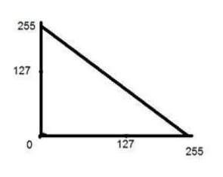

**S = T(r) or S = L -1 – r.**

Where r= Gray level value at pixel (x,y)

L is the largest gray level consists in the image

It results in getting photograph negative.

It is useful when for enhancing white details

embedded in dark regions of the image.

1. **HISTOGRAM BASED TECHNIQUES** 
   * Histogram techniques are very effective and useful in many image processing applications.
   * Histogram is not only a effective tool for image quality assessment but also for manipulating the contrast and brightness of a image.
   * The histogram for a good image will have a flat profile or distribution of pixels.
   * The cumulative histogram can also be constructed form the individual histograms by taking the sum of the pixel counts.
   * The quality of the image can be controlled indirectly by controlling its histogram by normalizing it to a flat profile or by transforming it to a target histogram profile.

There are two methods of enhancing contrast. The first one is called Histogram stretching that increase contrast. The second one is called Histogram equalization that enhance contrast.

**Contrast -** Contrast is the difference between maximum and minimum pixel intensity.

**Histogram stretching**

The formula for stretching the histogram of the image to increase the contrast is

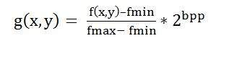

The formula requires finding the minimum and maximum pixel intensity multiply by levels of Gray. In our case the image is 8bpp, so levels of Gray are 256.

The minimum value is 0 and the maximum value is 225. So the formula in our case is

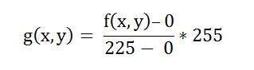

where f(x,y) denotes the value of each pixel intensity. For each f(x,y) in an image , we will calculate this formula.

After doing this, we will be able to enhance our contrast.

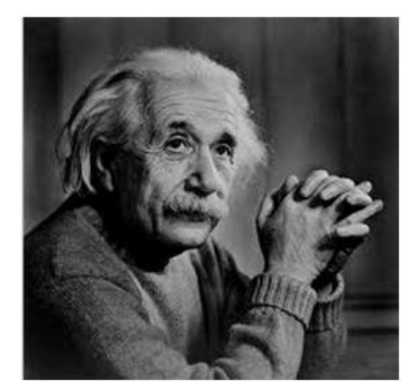

The following image appear after applying histogram stretching.

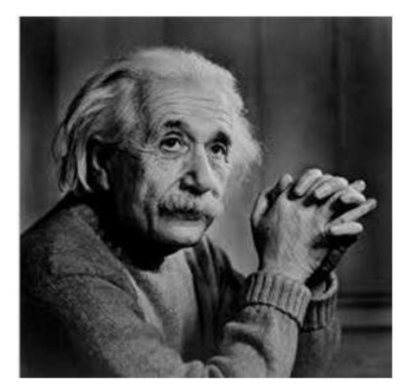

**HISTOGRAM EQUALIZATION**

* Histogram equalization is a common technique for enhancing the appearance of images. If we could `stretch out' the grey levels at the dark end to produce a more uniformly distributed histogram then the image would become much clearer.
* As the low-contrast image’s histogram is narrow and centered toward the middle of the gray scale, if we distribute the histogram to a wider range the quality of the image will be improved.
* Histogram equalization normalize the value by dividing the total number of pixels.
* Histogram equalization distributes the gray level to reach the maximum gray level because the cumulative distribution function equals 1 when 0 ≤ r ≤ L-1.
* Histogram equalization may not always provide the desired effect because its aim is to evenly distribute the pixels.

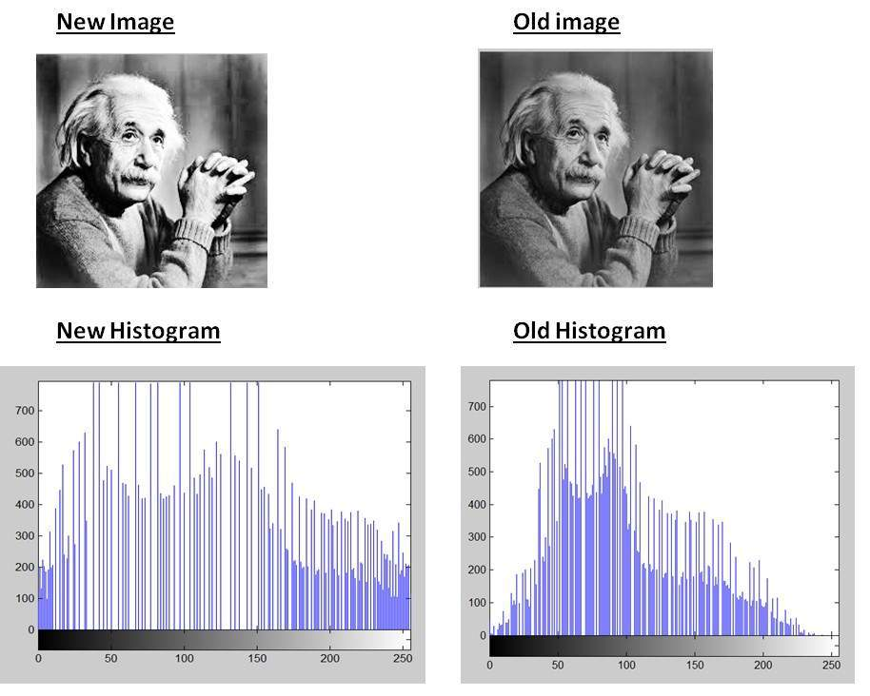

* + 1. **Spatial Filtering**

Filtering operations that are performed directly on the pixels of an image, are referred as Spatial Filtering.

The process of spatial filtering consists simply of moving the filter mask from point to point in an image. At each point(x, y), the response of the filter at that point is calculated using a predefined relationship. For linear spatial filtering the response is given by a sum of products of the filter coefficients and the corresponding image pixels in the area spanned by the filter mask. For the 3*3 mask the result R, of linear filtering with the filter mask at a point (x, y) in the image is

**R=w(-1, -1)f(x-1,y-1)+w(-1, 0)f(x-1, y)+…..**

**+w(0,0)f(x, y)+…+w(1,0)f(x+1,y)+w(1,1)f(x+1,y+1),**

which we see is the sum of products of the mask coefficients with the corresponding pixels directly under the mask.

**Objective of filters-**

1. Smoothing filters are used for blurring and for noise reduction.
2. Blurring is used in pre-processing steps, such as removal of small details from an image prior to object extraction and bridging of small gaps in lines or curves.
3. Noise reduction can be accomplished by blurring with a linear filter and also by linear and also by nonlinear filtering.
4. The principal objective of sharpening is to highlight fine detail in image or enhance detail that has been blurred, either in error or as a natural effect of a particular method of image acquisition.
5. Uses of image sharpening vary and include applications ranging from electronic printing and medical imaging to industrial inspection and autonomous guidance in military systems.

**Two types in spatial filter-**

**Image Smoothing Spatial Filters**

It is linear filter, creates image with an smooth appearance or to removing the noise such as Gaussian noise.

**Image Sharpening Spatial Filters**

It is highlight fine detail in an image or to enhance detail that has been blurred, either in error or as a natural effect of a particular method of image acquisition.

* + - 1. **Image Smoothing Spatial Filters**

**1. Box filter**

Box filtering is basically an average-of-surrounding pixel kind of image filtering. It is actually a convolution filter which is a commonly used mathematical operation for image filtering. A convolution filters provide a method of multiplying two arrays to produce a third one. In box filtering, image sample and the filter kernel are multiplied to get the filtering result. The filter kernel is like a description of how the filtering is going to happen, it actually defines the type of filtering. The power of box filtering is one can write a general image filter that can do sharpen, emboss, edge-detect, smooth, motion-blur, etcetera. Provided appropriate filter kernel is used.

**2. Averaging filter**

Average (or mean) filtering is a technique for ’smoothing' photographs by lowering the intensity fluctuation between adjacent pixels. The average filter works by moving through the image pixel by pixel, replacing each value with the average value of neighbouring pixels, including itself. Also called Normalized of box filter.

**3.Gaussian filter**

A Gaussian filter is a linear filter. It's usually used to blur the image or to reduce noise. If you use two of them and subtract, you can use them for "unsharp masking" (edge detection). The Gaussian filter alone will blur edges and reduce contrast.

**4. Min filter**

The minimum filter is defined as the minimum of all pixels within a local region of an image. The minimum filter is typically applied to an image to remove positive outlier noise.

This filter is useful for finding the darkest points in an image. Also, it reduces salt noise as a result of the min operations.

The 0th percentile filter is MinFilter:

***f^ (x, y) = min(s,t)eSx,y{g(s,t)}.***

**5. Max filter**

The maximum filter is defined as the maximum of all pixels within a local region of an image. The maximum filter is typically applied to an image to remove negative outlier noise

***f^ (x, y) = max(s,t)eSx,y{g(s,t)}.***

**6. Median filter**

Replaces the value of a pixel by the median of the gray levels in the neighborhood of that pixel (the original value of the pixel is included in the computation of the median)

Quite popular because for certain types of random noise (impulse noise 🢡 salt and pepper noise), they provide excellent noise-reduction capabilities, with considering less blurring than linear smoothing filters of similar size.

***F^(x, y) = median(s,t)eSx,y{g(s,t)}***

* + - 1. **Image Sharping Spatial Filters**

It is also known as derivative filter. The purpose of the sharpening spatial filter is just the opposite of the smoothing spatial filter. Its main focus in on the removal of blurring and highlight the edges. It is based on the first and second order derivative.

1. **First Order Derivative**

Must be zero in flat segments.

Must be non-zero at the onset of a grey level step.

Must be non-zero along ramps.

First order derivative in 1-D is:

***f' = f(x+1) - f(x)***

Filters we use Sobel Filter.

**Sobel Filter**

Sobel edge detector is a gradient based method based on the first order derivatives. It calculates the first derivatives of the image separately for the X and Y axes.

The operator uses two 3*3 kernels which are convolved with the original image to calculate approximations of the derivatives - one for horizontal changes, and one for vertical. The picture below shows Sobel Kernels in x-dir. and y-dir.:

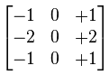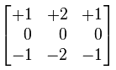

1. **Second Order Derivative**

Must be zero in flat areas.

Must be zero at the onset and end of a ramp.

Must be zero along ramps.

Second order derivative in 1-D is:

***f'' = f(x+1) + f(x-1) - 2f(x)***

Use Laplacian operator and find result.

**Laplacian filter**

Unlike the Sobel edge detector, the Laplacian edge detector uses only one kernel. It calculates second order derivatives in a single pass.

A kernel used in this Laplacian detection looks like this:

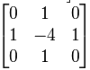

If we want to consider the diagonals, we can use the kernel below:

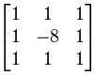

* 1. **Frequency Domain**

Frequency domain filters are used to smooth and sharpen the image by removing high or low frequency components. Sometimes it is possible to suppress the very high and the very low frequency. Frequency domain filters are different from spatial domain filters in that they focus primarily on the frame rate. Basically this is done for two basic operations namely smoothing and sharpening.

A filter that attenuates high frequencies while “Passing” low frequencies is called a lowpass filter. A filter that has opposite characteristic is appropriately called a high pass filter.

* + 1. **Filter**

There are 2 filters.

**2.5.1.1 Low pass Filter**

Low pass filter removes the high frequency components that means it keeps low frequency components. It is used for smoothing the image. It is used to smoothen the image by attenuating high frequency components and preserving low frequency components.  
Mechanism of low pass filtering in frequency domain is given by:

G(u, v) = H(u, v) . F(u, v)

where F(u, v) is the Fourier Transform of original image

and H(u, v) is the Fourier Transform of filtering mask

**Types of low pass filter-**

1.Ideal Lowpass

2.Butterworth Lowpass

3.Gaussian Lowpass

**2.5.1.2 High pass filter**

High pass filter removes the low frequency components that means it keeps high frequency components. It is used for sharpening the image. It is used to sharpen the image by attenuating low frequency components and preserving high frequency components.  
Mechanism of high pass filtering in frequency domain is given by:

H(u, v) = 1 - H'(u, v)

where H(u, v) is the Fourier Transform of high pass filtering

and H'(u, v) is the Fourier Transform of low pass filtering

**Types of high pass filter:**

1.Ideal High pass

2.Butterworth High pass

**2.6 Steps in frequency filtering**

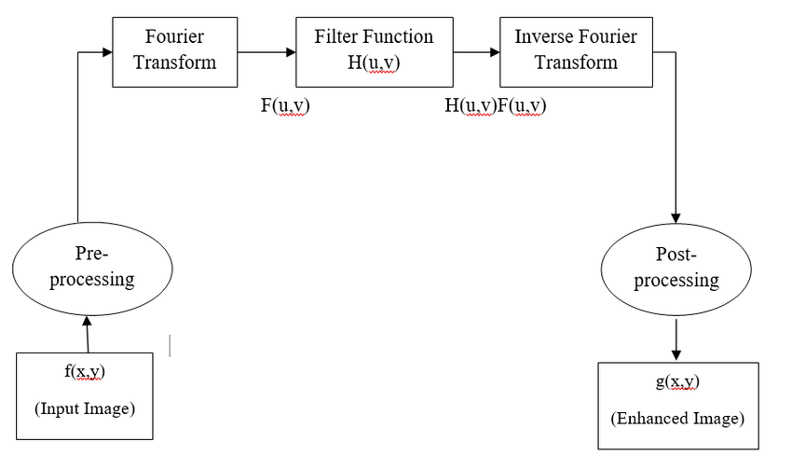

1. Data Flow Diagrams:
2. Context level diagram:

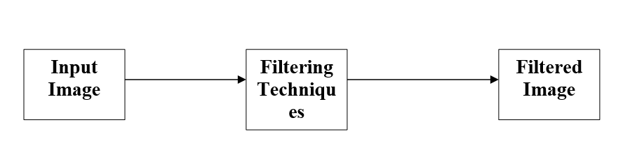

b. First Level Diagram:

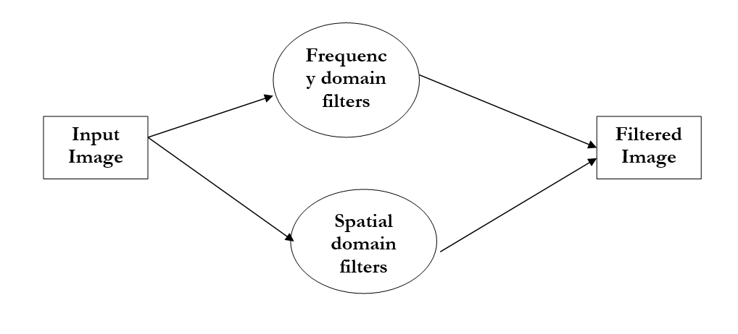

Hierarchical Chart:

**Spatial Domain Filter**

**Averaging Filter**

**Box Filter**

**Gaussian Filter**

**Min Filter**

Max Filter

Median Filter

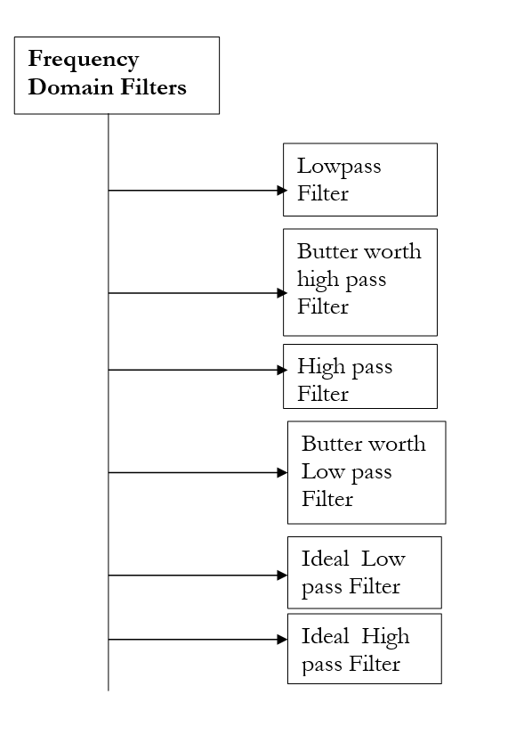

**Chapter 4. System Requirement & Specification**

In our project we require various PYTHON library..

* opencv library
* matplotlib library
* skimage library
* PIL library
* scipy library
* numpy library
* tkinter

Requirements to develop the Application:

* Any laptop or desktop with an active internet connection.
* Processor: Intel i5.
* RAM: 4 GB minimum, 8 GB recommended.
* Storage: 2 GB of available disk space minimum, 4 GB recommended.

**Chapter 5 . EXPERIMENT:**

**Image Negative:**

def imagenegative(self):

img = cv2.imread(f"{self.name}")

img1 = 255-img

self.showOutput(img1)

**Snapshot:**

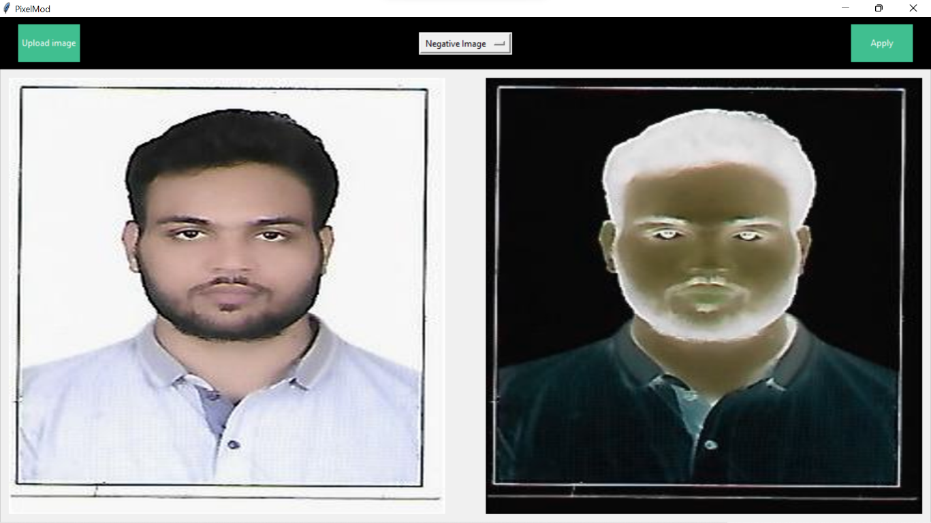

**Log transformation:**

def logtransformation(self):

# Read an image

image = cv2.imread(f"{self.name}")

# Apply log transformation method

c = 255 / np.log(1 + np.max(image))

log_image = c * (np.log(image + 1))

# Specify the data type so that

# float value will be converted to int

log_image = np.array(log_image, dtype=np.uint8)

self.showOutput(log_image)

**Snapshot:**

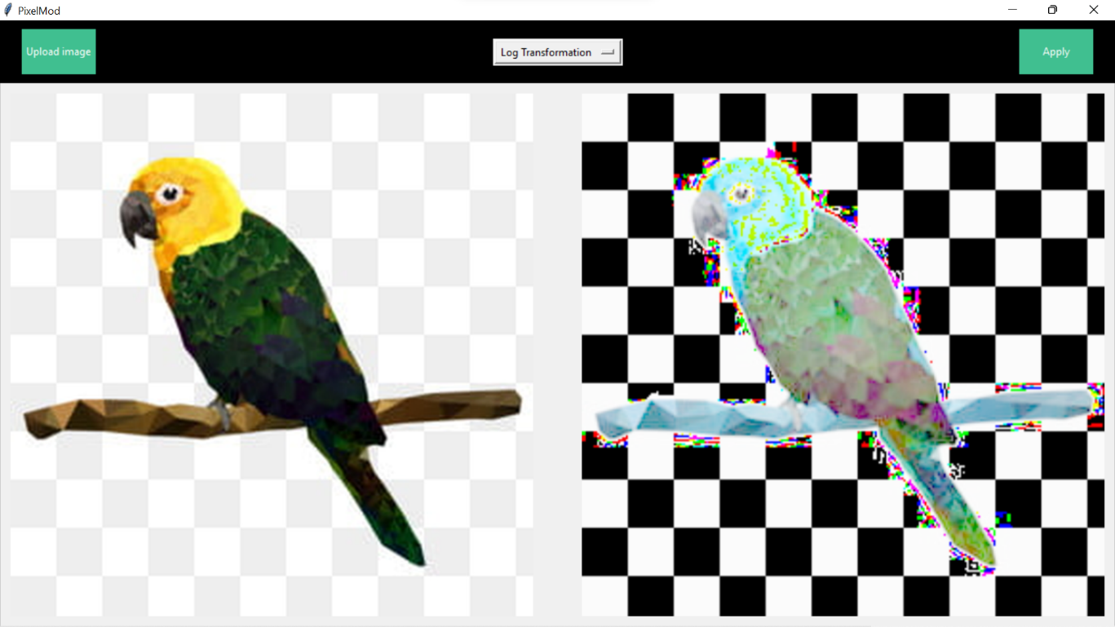

**Denoising:**

def denoisingimage(self):

img = cv2.imread(f"{self.name}")

# denoising of image saving it into dst image

dst = cv2.fastNlMeansDenoisingColored(img, None, 10, 10, 7, 15)

self.showOutput(dst)

**Snapshot:**

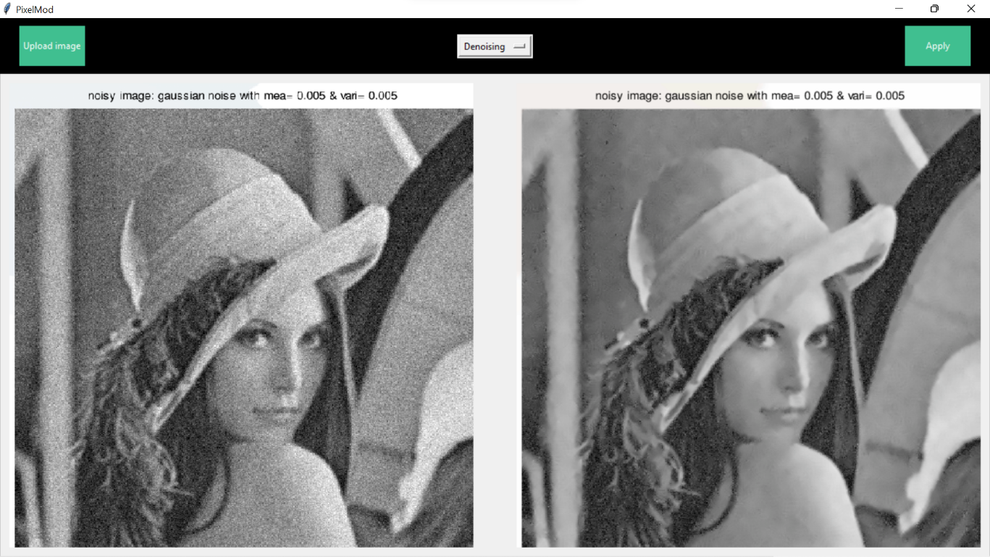

**Box filter:**

def boxfilter(self):

img = cv2.imread(f"{self.name}")

blur = cv2.blur(img, (3, 3))

self.showOutput(blur)

**Snapshot:**

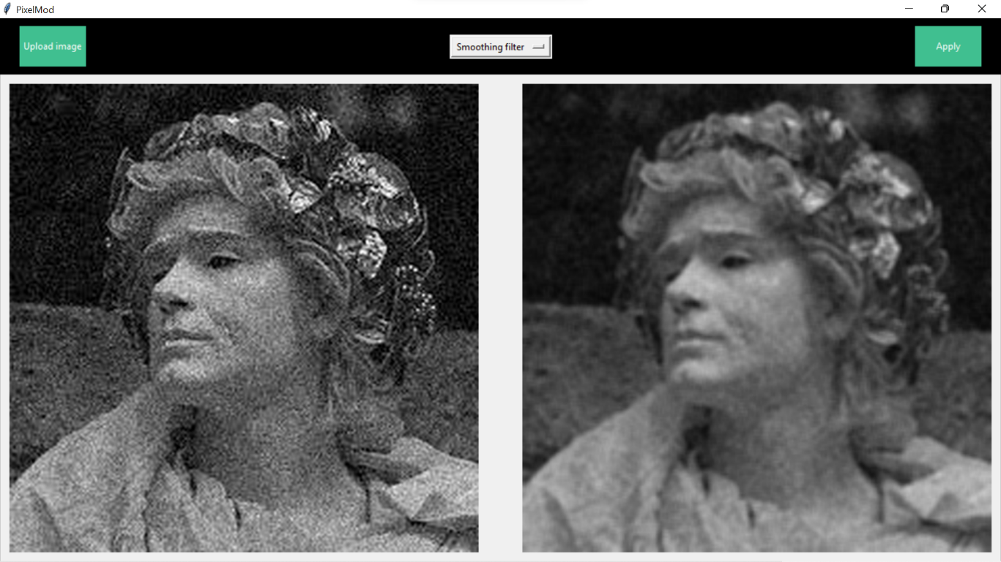

**Gaussian filter:**

def gaussianfilter(self):

img = cv2.imread(f"{self.name}")

blur = cv2.GaussianBlur(img, (5, 5), 0)

self.showOutput(blur)

**Snapshot:**

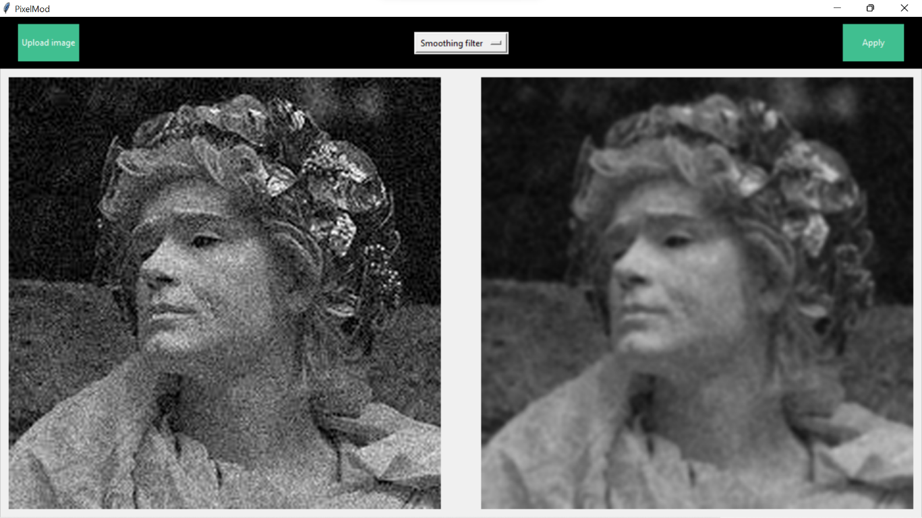

**Median filter:**

def medianfiltering(self):

img = cv2.imread(f"{self.name}")

median = cv2.medianBlur(img, 5)

self.showOutput(median)

|  |
| --- |
|  |

**Snapshot:**

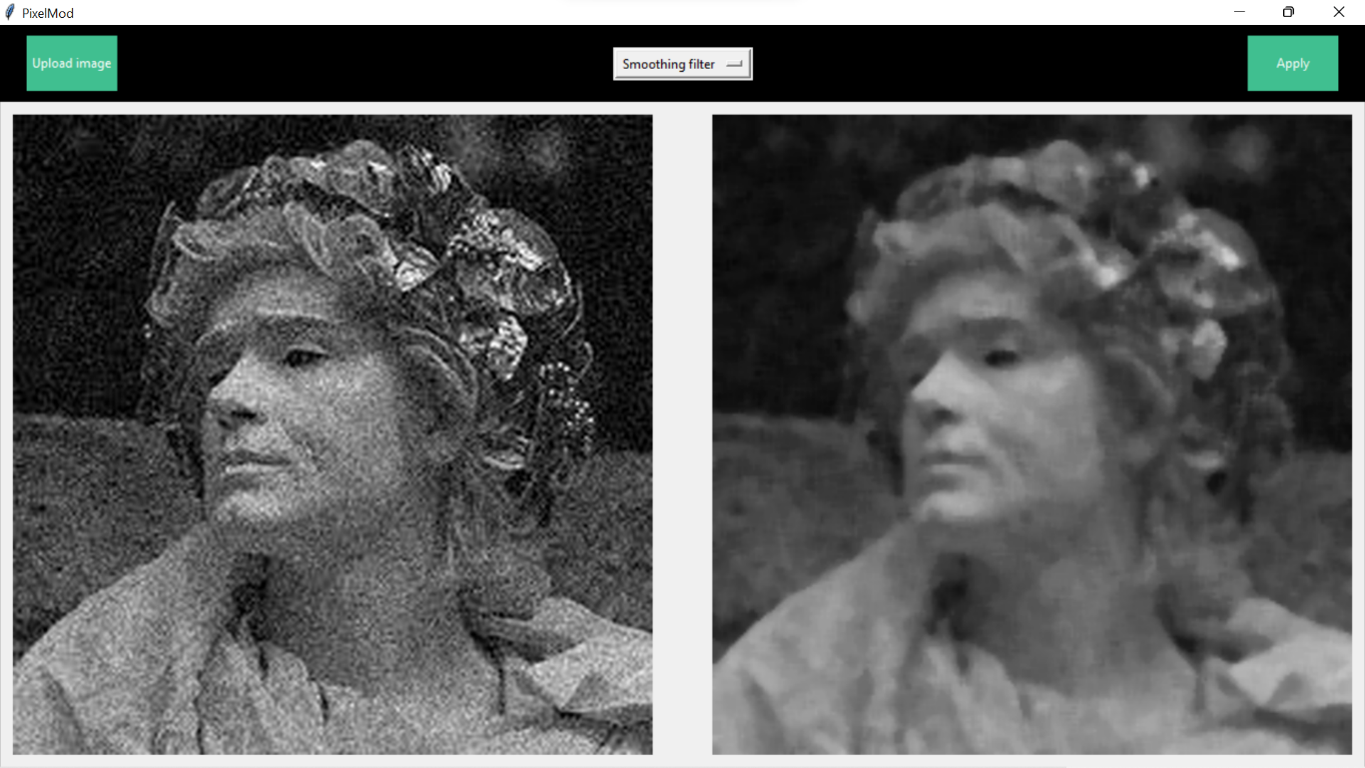

**Averaging filter:**

def averagingfilter(self):

img = cv2.imread(f"{self.name}")

kernel = np.ones((3, 3), np.float32)/9

dst = cv2.filter2D(img, -1, kernel)

self.showOutput(dst)

**Snapshot:**

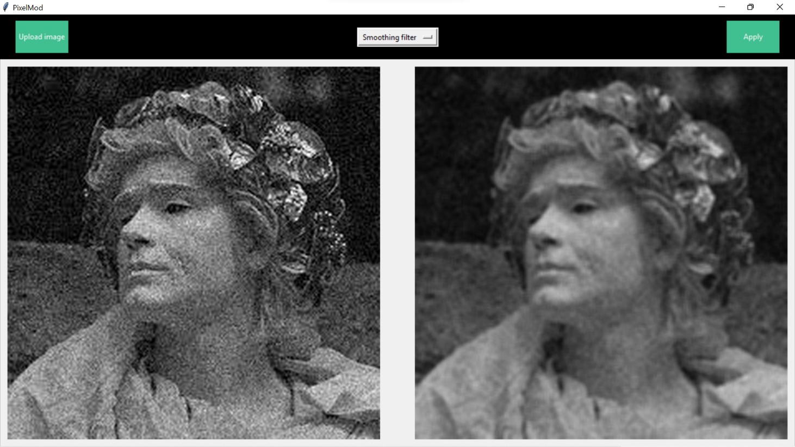

**Canny Algorithm:**

def cannyalgo(self):

img = cv2.imread(f"{self.name}")

# Convert to graycsale

img_gray = cv2.cvtColor(img, cv2.COLOR_BGR2GRAY)

# Blur the image for better edge detection

img_blur = cv2.GaussianBlur(img_gray, (3, 3), 0)

# Canny Edge Detection

edges = cv2.Canny(image=img_blur, threshold1=100, threshold2=200)

self.showOutput(edges)

**Snapshot:**

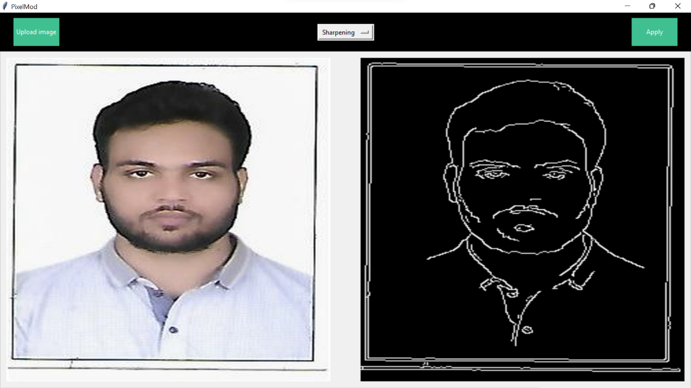

**Function for showing output:**

#for showing output

def showOutput(self,img=None)

for item in self.rightframe.winfo_children():

print(item)

item.destroy()

img =cv2.resize(img,(600,600))

self.photo1 = ImageTk.PhotoImage(Image.fromarray(img))

image_label2 = Label(self.rightframe, image=self.photo1)

image_label2.pack()

**Chapter 6. Future Scope**

There is enormous scope for application in the real world. It’s just a matter of bringing up ideas to manage and present a platform that can eventually be used by the users widely to make their life a little easier.

Some of the features that we have thought of, to incorporate in our application in the future are as follows:

* Apply Fourier Transformation
* Saving Image
* Drag and drop feature
* User input for brightness and contrast.

**Chapter 7. Conclusion**

The image enhancements techniques play a significant position in digital image processing. It's shown in this study that the nonlinear image enhancement can be utilized to improve the quality of a blurred image by using the concept of the light source refinement. Image enhancement algorithms offer a wide variety of approaches for modifying images to achieve visually acceptable images. The choice of such techniques is a function of the specific task, image content, observer characteristics, and viewing conditions.

The choice of the technique is depending upon the requirement. The histogram equalization method is powerful comparing to other methods. The Gray levels of an image that has been subjected to histogram equalization are spread out and always reach white. This process increases the dynamic range of Gray levels and, consequently, produces an increase in image contrast. In images with narrow histograms and relatively few Gray levels, affect visual graininess and patchiness. Histogram method significantly improved the visual appearance of the image.

**REFERENCES**

**Books:**

1. Digital Image Processing by S. Sridhar

2. Python

**Websites:**

1. <www.tutorialspoint.com>
2. <www.w3schools.com>
3. [www.slideshare.net](http://www.slideshare.net)
4. [www.researchgate.net](http://www.researchgate.net)
5. [www.getbootstrap.com](https://www.getbootstrap.com)
6. [www.msdn.microsoft.com](http://www.msdn.microsoft.com)
7. [www.slideshare.com](http://www.slideshare.com)
8. <https://numpy.org/>
9. <https://docs.python.org/3/library/tkinter.html>
10. <https://opencv.org/>
11. <https://pypi.org/project/Pillow/>
12. <https://www.geeksforgeeks.org/>